ENTWINE MODULES
Module 1 — Asset Registry
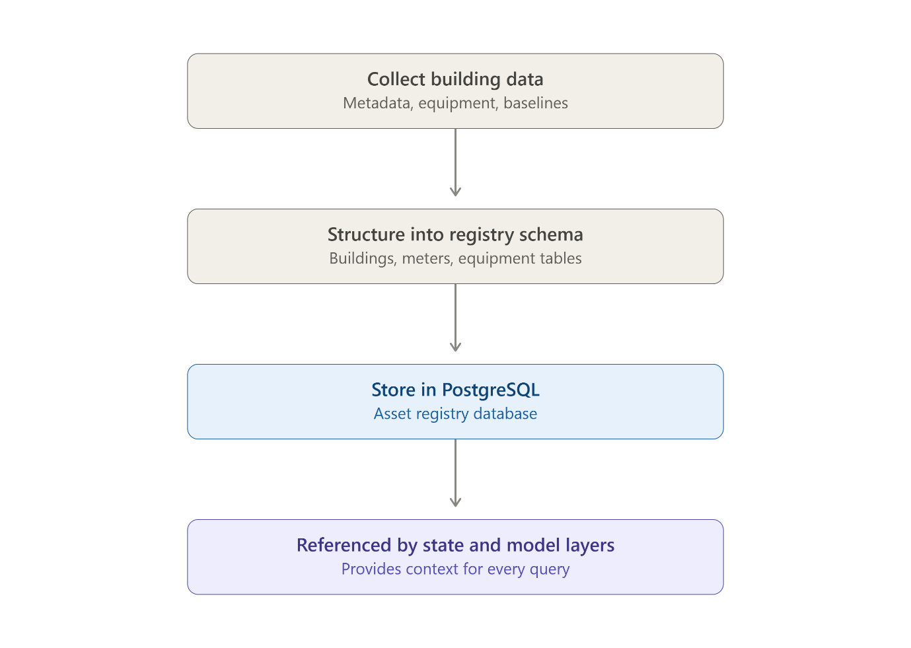
Module 2 — State Layer
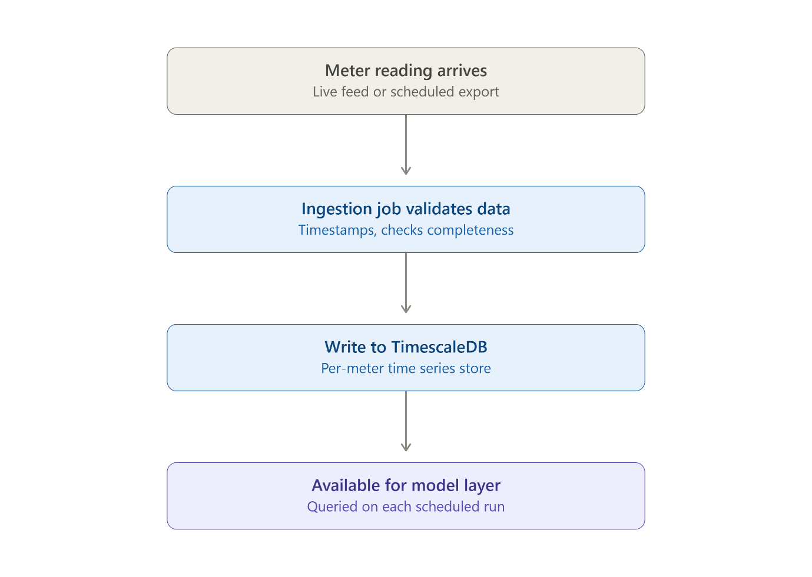

Module 3 — Model Layer (GridReason runs first, and only a flagged anomaly triggers the counterfactual and audit steps)
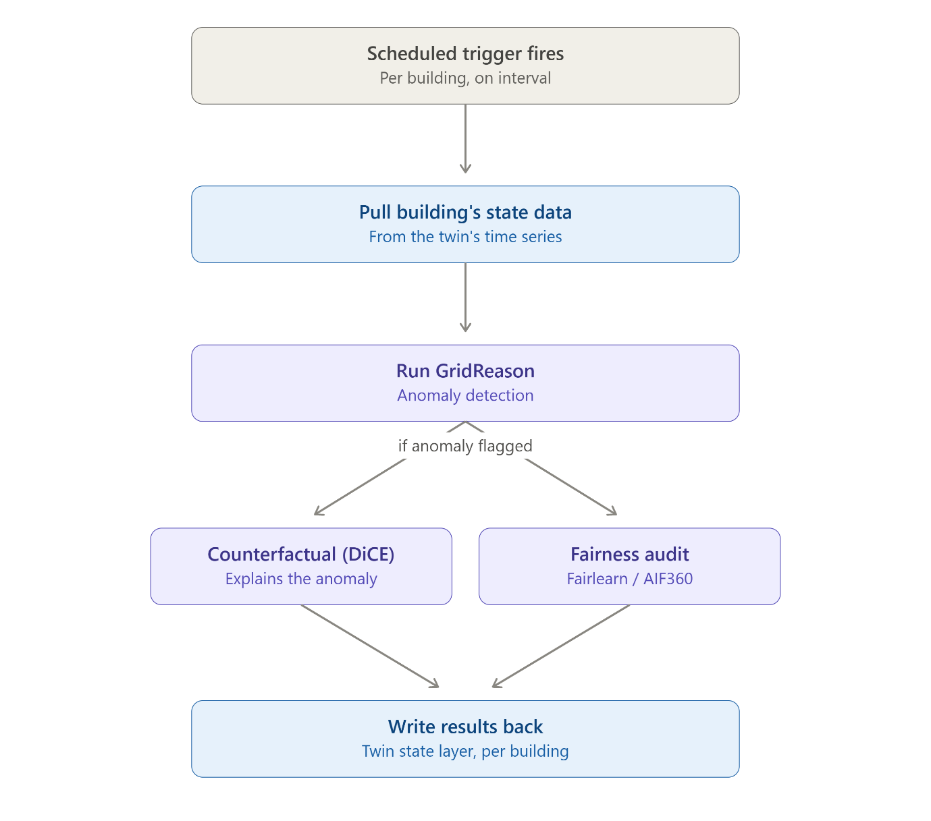
Module 4 — Interrogation Layer
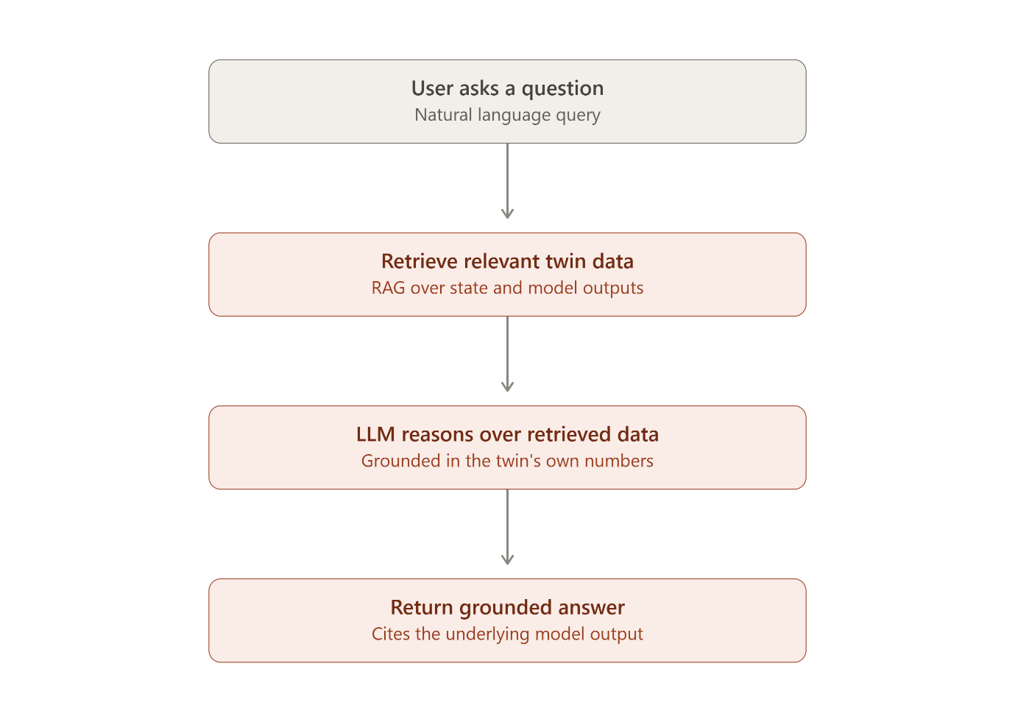
Module 5 — Dashboard
